Pop Culture Detective

As we gear up for the final assignment—and your final display of analytical prowess--of the semester which will see you investigate and make an argument about an aspect or artifact of popular culture, it can be helpful to immerse ourselves in displays of this kind of cultural work. To that end, this assignment invites you to explore The Pop Culture Detective Agency’s YouTube channel.

Check out their work here: https://www.youtube.com/channel/UCHiwtz2tCEfS17N9A-WoSSw and pick an episode that appeals to you to watch (they have work on The Big Bang Theory, The Last Jedi, Stranger Things, 80s movies, video games, etc, so pick one from their library that best ties into your own interests/experiences/media habits.
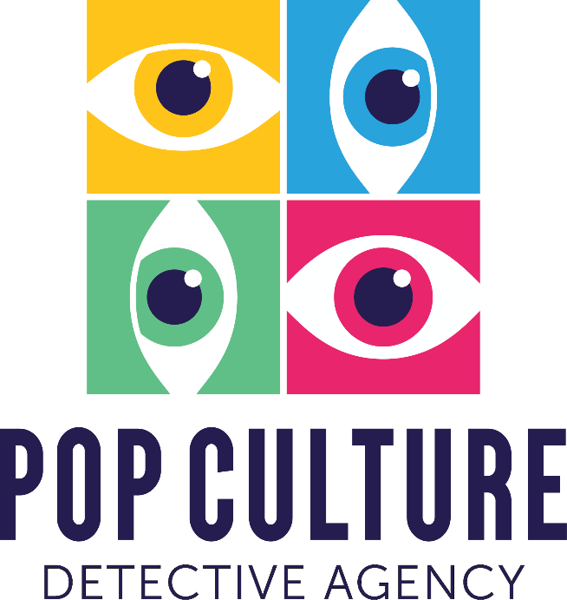
Should you not find anything you like, you might also expand into the work of video essayist Lindsay Ellis, channel link: https://www.youtube.com/channel/UCG1h-Wqjtwz7uUANw6gazRw although her pieces are typically more niche and may require more context/familiarity with the material under discussion to be as successful and accessible as the pop culture detective videos. Additionally, if video isn’t your mode or you don’t see something you like, you might try out the You’re Wrong About podcast. While they offer more of a retrospective take than strictly contemporary in pop culture analysis, their depth of analysis and questions into why it matters to think about now are excellent models. (If you’re interested in sports, check out the Tonya Harding episodes exploring sports performance (and the unspoken intersecting rules of performing gender and class in ice skating); if you’re interested in engineering or project management, check out the episode investigating The Challenger Disaster : https://podcasts.apple.com/us/podcast/youre-wrong-about/id1380008439 ).

After viewing these models of investigations akin to what you might produce in your own final project and your own role as pop culture detectives, write a short (1-2 page) reflection to post to ICON. Share a bit about what you learned from the video (what is its argument, what’s interesting, why does investigating or asking critical questions of their subject matter) and try to also include some more meta-reflection on these videos as analyses (what did the rhetor’s of these videos do to make good arguments? What good moves might you borrow/transfer into your own writing/ thinking/speaking processes?).

